**Experimental procedure for the 500 foot moored balloon test**

Formulated August 4, 2019 for use by the Engineering Mechanics and Space Systems Laboratory

North Carolina State University

Engineering Building III, Room 3406

The following procedure as described is to be followed while performing 500 foot moored balloon test. The steps are grouped in sections with each section having a stage number.

**Prep and travel procedure (all)**

1. The team is to arrive at the lab on the morning of the test several hours prior to launch. All items for the test, equipment to be used, and other items needed should be packed and labeled clearly before the team leaves the lab. The packing checklist of all items required must be completely filled out before the team may leave the lab.
2. All test items are to be transported from the lab to the launch site. All parties driving should be made aware of the launch site and route.
3. Once at the launch site, the team is to unpack all items and distribute them in such a manner which the entire team is aware of the location of each item. Tarps are suggested in order to space everything out on the ground for ease of visibility. A pop-up tent is suggested to provide shade to all parties.

**Balloon inflation procedure (3 people)**

1. Begin the balloon inflation process. To do so, allow one team member to hold the balloon and restrain the balloon from touching the ground and lifting off prematurely (this person needs to have latex gloves on to handle the balloon). A second team member is responsible for clamping the neck of the balloon to the nozzle of the inflating assembly and is also responsible for preventing a premature ascent (also with latex gloves). A third team member should be regulating the amount of helium flowing into the balloon (no gloves needed).
2. Place the neck of the balloon on the inflation tube.
3. Place the aluminum balloon restraints on either side of the balloon neck. Place two hose clamps around the balloon restraint pieces.
4. Place the handles around the base of the balloon inflation tube. Place the third hose clamp around the handle pieces.
5. Tie two tethers from the inflation handles to a carabiner (or clip) that are both a double length. One should be 1 foot long and clip to the fish scale. The second is a safety line, be two feet long, and clip to a stake in the ground (safety line). The other end of the fish scale should attach to a tether also anchored to a stake in the ground.
6. Inflate the balloon until the balloon contains enough helium to generate **X.XX kg** of lift (based on the weight of the system known beforehand). To measure the lift, gently let go of the handles and let the fish scale take the load. Once at the desired inflation volume, attach the tie down tether to the balloon stem (this tether is to tie the balloon to a car for ease of working with the balloon after inflation and before launch).

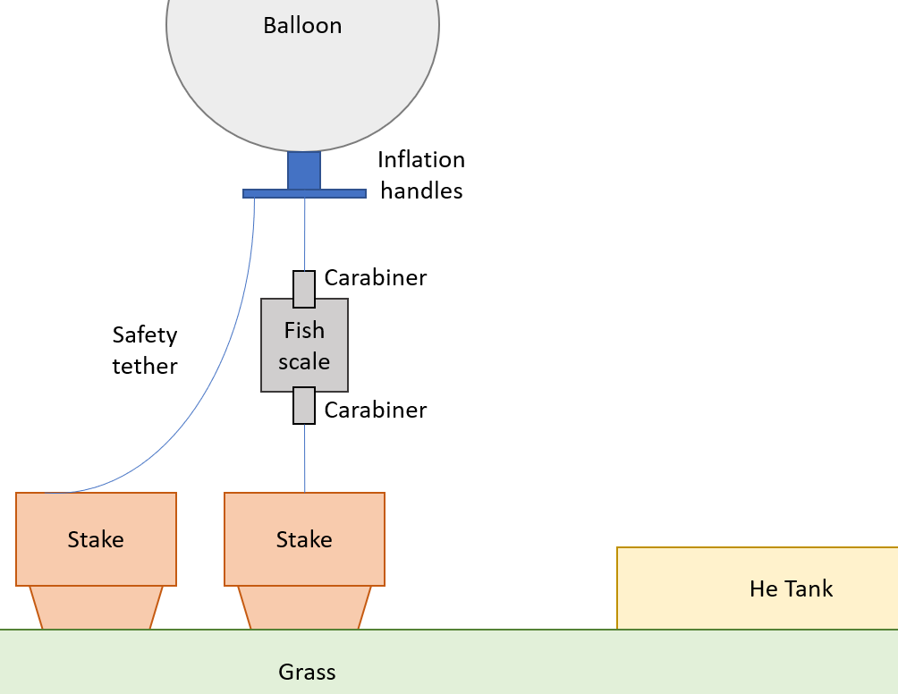

1. Attach the connecting tether to the balloon stem. Fold the balloon stem so that the open end of the stem is pointed upwards. Tie off the stem to prevent helium from leaking out of the balloon. Secure the tie off using electrical tape. Tie the other end of the connecting tether to an anchor to prevent it from flying away.

**Tether preparation procedure (1 person)**

1. Layout and fix enough stakes in the ground as needed (should be 20 stakes for 500 ft). The 1st stake will also act as the anchor point for the main tether.
2. Both groups will be driven into the ground to form 2 straight parallel lines. The two lines will be 25 feet apart from each other. The arrangement of the stakes is a sketched below.

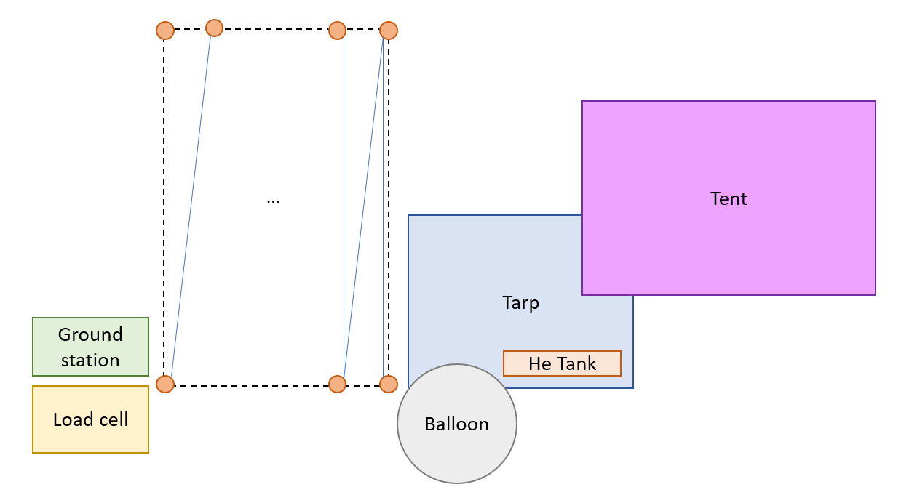

1. Tie one end of the main tether to the 1st stake tether. Then layout the tether such that it zig-zags between the two parallel lines of the stakes.

**NOTE: After the tether has been placed along the stakes, the tether is hard to see against the green grass. No team member should walk in between the two parallel lines of stakes as this presents a tripping hazard. If it is imperative that a team member pass between the two lines of stakes, that team member should only walk in a perpendicular line from one side of the stakes to the other as to prevent tripping as much as possible.**

1. At each streamer location (every 50 feet), cut a streamer to length. Attach the streamer to the tether (at one streamer end) using duct tape.
2. The opposite end of the mooring line should be connected to the load cell. To do so,

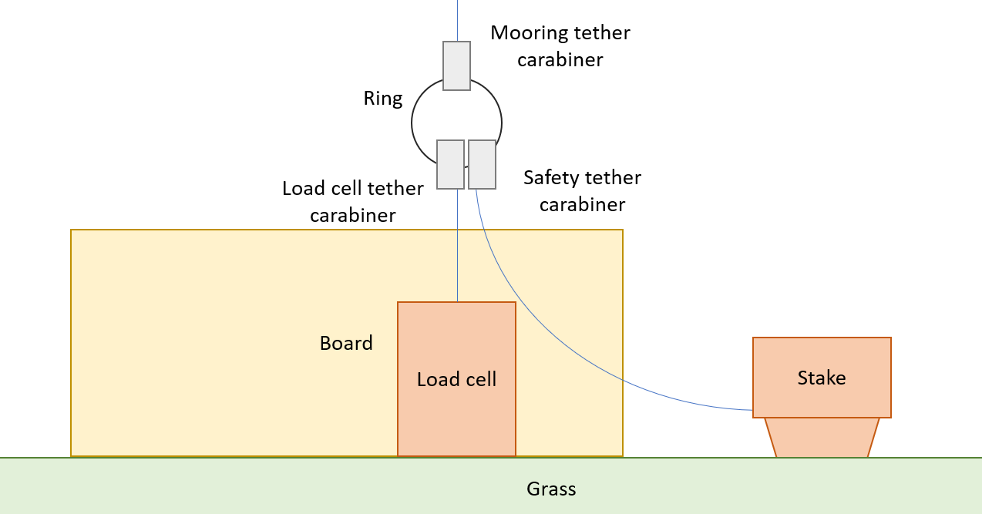

**Sensor node preparation procedure (Stage 2)**

1. Load code onto the tether nodes and the gondola circuit.
   1. Connect the USB micro cable to the computer and to the Arduino Micro.
   2. Open the Arduino IDE on the computer.
   3. Open the sensor node Arduino code.
   4. Set the Board to the Arduino Micro.
   5. Set the Port to COM Port 10.
   6. Push the code to the Arduino.
   7. Once the code is done, change the COM port back to 10.
   8. Wait two seconds and then open the serial monitor.
   9. Connect the battery to the red and green leads on the proto board.
   10. Remove the cable from the Arduino.
2. Put the tether nodes into the corresponding Tupperware containers and duct tape these containers to the washers which are already fixed on the tether.

**Gondola preparation procedure (Stage 2)**

1. Load the code onto the gondola circuit.
   1. Connect the USB serial cable to the computer and to the Arduino Mega.
   2. Open the Arduino IDE on the computer.
   3. Open the gondola Arduino code.
   4. Set the Board to the Arduino Mega 2560.
   5. Set the Port to COM Port (Mega).
   6. Push the code to the Arduino.
   7. Switch the switch closed.
   8. Remove the cable from the Arduino.
2. Slide the gondola circuit into the gondola. The close up the gondola by attaching the tail cap and the then duct the tail cap to prevent it from coming loose.

**Ground station procedure (Stage 2)**

1. Assemble the ground station weather vane and anemometer. Using the set screws, place the weather vane shaft onto the slip ring. Place the anemometer shaft onto the encoder shaft using the three set screws.
2. Place the ground station at a known distance from stake 1 and at an elevation of approximately 6 feet from the ground. If placing the ground station on top of a car, be sure to prevent the screws in the underside of the ground station from scratching the paint on the car.
3. Push the code onto the Arduino Uno used for the ground station.
   1. Connect the USB serial cable to the computer and to the Arduino Uno.
   2. Open the Arduino IDE on the computer.
   3. Open the ground station Arduino code.
   4. Set the Board to the Arduino Uno.
   5. Set the Port to COM Port (Uno).
   6. Push the code to the Arduino.
   7. Connect the battery to the Arduino board.
   8. Remove the cable from the Arduino.
4. Verify the wind is strong enough to move the weather vane and the anemometer.
5. Once erected, measure the distance from the ground station to stake 1. Document this distance. Document (via camera and pictures) the location of the ground station (and stake 1) relative to a physical landmark (this landmark should be viewable from the satellite images from Google Maps. Thus, look for a cluster of trees, bushes, shrubberies, etc.).

**Attachment procedure (Stage 3)**

1. Attach the High Altitude Balloon Tracker to the gondola using a tether segment such that the tracker is positioned underneath the balloon. To do this, tie the tether to the underside of the gondola (via the hook) and pass the tether segment through both structural holes on the tracker. Tie the opposite end to the underside of the gondola (via the hook).
2. Pass the main tether through both structural loops on the tracker and tie the end of the main tether to the underside of the gondola (via the hook). Make sure the opposite end of the main tether is attached to the ground anchor. This allows the tracker to be fixed to the main tether but not act as a load bearing member.
3. Wrap the Ni-Cr wire around the connecting tether above the gondola and below the balloon. Run the connecting wires to the gondola and connect them. See figure 6 for a visual description of the system.
4. Attach the Go Pro to the tracker via the adhesive base attachment. Point the camera downwards such that the tether may be observed.

**Ascent, test, and descent procedure (Stage 4)**

1. Cut the connecting tether. While doing this ensure that one team member is stopping the 1st stake from coming out.
2. Once the tether up to stake 40 has been pulled up by the balloon, allow time for the system to settle (this should be the amount of time it takes for a team member to walk between perpendicular stakes). The team member should hold the removed stake in hand and walk from stake 40 to stake 39 while controlling the ascent rate using the stake.
3. Remove stake 39 to allow the next 25 meters of tether to be pulled up by the balloon. Ensure that stake number 38 does not get pulled out during the process. Walk to the next stake.
4. Repeat this process until all stakes **(EXCEPT STAKE 1)** have been removed. (NOTE: stake 1 is never removed from the ground until the entire experiment has been completed).
5. Leave the system alone for approximately 5 minutes before you start reeling the tether back in. It is advised that the team take a small break to rest. Members who have performed rigorous tasks should swap position with other members who have not performed rigorous tasks to allow ample rest for all members. Once aloft, the system should resemble figure 7.
6. Retrieve 25 meters of the tether. This can be accomplished by running the main tether through a hook on a removed stake and walking with the tether for 25 meters. Repeat this process with new stakes each time in a manner such that the initial configuration of the main tether and the stakes is recreated.

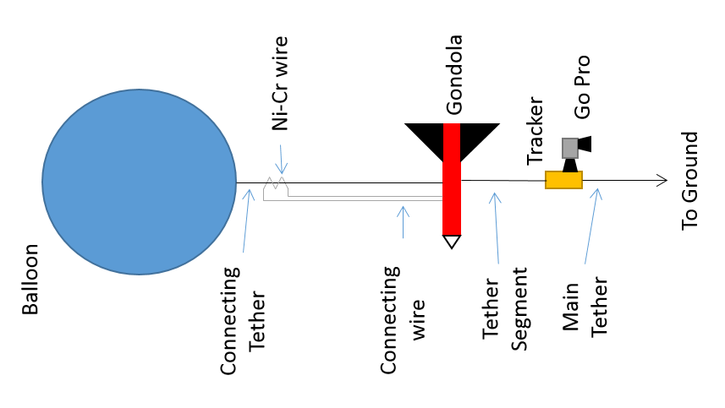

**Figure 6:** Gondola connecting diagram

1. Upon reaching a tether node, make sure the node is anchored to the ground via a stake. The walking team member should continue the walk while another team member disassembles the tether node. Documentation of which number node comes down is key.
2. Repeat this process for all other tether nodes. Once stake number 40 has been fixed again, pull down the balloon and the gondola.
3. Verify that all the tether nodes and washers are removed from the tether.
4. Repeat the launch procedure to launch the balloon with only the gondola on the tether. Fly the balloon for approximately 5 minutes. Retrieve the balloon by the same procedure as before.

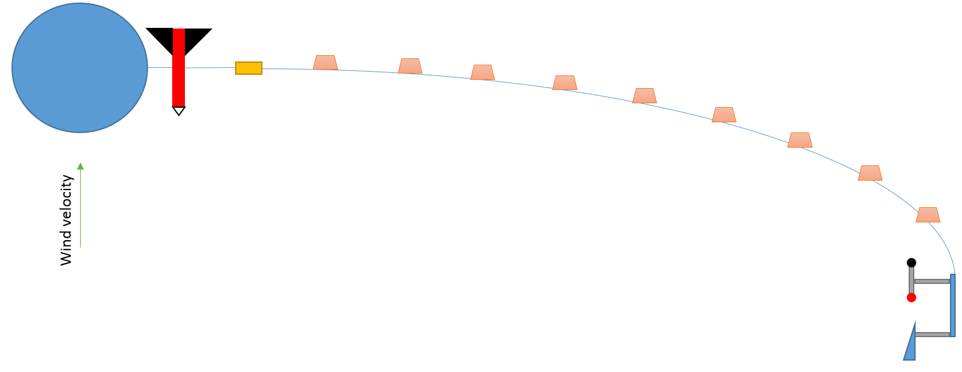

**Figure 7:** Balloon system at full height

**Pack up procedure (Stage 5)**

1. Remove the circuit from the gondola and retrieve the SD card. Tie the balloon to the connecting tether again so that it does not fly away.
2. Disconnect the connecting tether from the balloon. Remove the tape from the balloon stem and remove the rubber bands. Slowly let the helium out of the balloon.
3. Wind up the tether and pack the balloon away. Collect all washers and sensor packets and load the cars.
4. Upon returning to the lab, store all balloon containers in the appropriate locations within the lab. Upload the data to a secure place (Google Drive) for post processing purposes later. Document all issues and notes from the test.

# Appendix A: Packing checklist for the 1000 meter test

This checklist is meant to be used before leaving the lab on the morning of the flight and before leaving the launch site to return to the lab. The purpose is to make sure all items borrowed from the lab and items associated with the experiment are taken for use and returned to the lab.

|  |  |  |
| --- | --- | --- |
| **To** | **From** | **Item** |
| [ ] | [ ] | Balloon; one for launch and at least one backup |
|  |  |  |
| [ ] | [ ] | Helium (one large tank, two small tanks) |
|  |  |  |
| [ ] | [ ] | Tethers; main tether, connecting tether, tie down tether, flight spool tether, plus extra for emergency repair |
|  |  |  |
| [ ] | [ ] | Sensor nodes (bags, bubble wrap, sensors, batteries); ten total |
|  |  |  |
| [ ] | [ ] | Gondola and extra cardboard for emergency repairs |
|  |  |  |
| [ ] | [ ] | Washers |
|  |  |  |
| [ ] | [ ] | Gondola sensors (batteries, electronics package, magnetometer) |
|  |  |  |
| [ ] | [ ] | Gondola emergency cut down system (analog electronics, parachute, nichrome wire, batteries); extra nichrome wire and batteries |
|  |  |  |
| [ ] | [ ] | Scientific notebooks for documentation |
|  |  |  |
| [ ] | [ ] | Pens/Pencils for writing |
|  |  |  |
| [ ] | [ ] | Blanket and tarps (workstations) |
|  |  |  |
| [ ] | [ ] | Ground station electronics (batteries, sensors) |
|  |  |  |
| [ ] | [ ] | Duct tape |
|  |  |  |
| [ ] | [ ] | Electrical tape |
|  |  |  |
| [ ] | [ ] | Tools (wrenches, screwdrivers, utility knife, superglue) |
|  |  |  |
| [ ] | [ ] | Computer (laptop) for post processing on site to verify data collection |
|  |  |  |
| [ ] | [ ] | Gloves for tether manipulation |
|  |  |  |
| [ ] | [ ] | Latex gloves |
|  |  |  |
| [ ] | [ ] | Rubber bands for tying off balloons |
|  |  |  |
| [ ] | [ ] | Copy of all experimental procedures, goals, etc. for reference |
|  |  |  |
| [ ] | [ ] | Pressure regulator assembly |
|  |  |  |
| [ ] | [ ] | Fish scale and associated batteries (digital) |
|  |  |  |
| [ ] | [ ] | Anchor and hammer |
|  |  |  |
| [ ] | [ ] | CoW copies and signed documentation |
|  |  |  |
|  |  |  |
|  |  |  |

# Appendix B: Pre-flight checklist for the 1000 meter test

Below is a checklist which must be completed before flight may occur. It is up to one team member who is independent of the preparation for the test to make sure that each item on the checklist is accounted for before flight begins.

|  |  |
| --- | --- |
| **Check** | **Task** |
| [ ] | Verify that all items on the packing checklist have been unpacked and placed on the ground in easy-to-identify locations. |
|  |  |
| [ ] | Verify the main tether is intact and has taped markings at 100 meter intervals for sensor node placements. |
|  |  |
| [ ] | Verify the tie down tether, the connecting tether, and the flight spool tether are intact. |
|  |  |
| [ ] | Assess the status of the gondola and make sure that the gondola is structurally intact and ready for flight. |
|  |  |
| [ ] | Make sure that the weather for the next three to four hours is clear and there is little chance of bad weather for the test. |
|  |  |
| [ ] | Erect the canopy for use in the test. |
|  |  |
| [ ] | Verify a car is in park within tie down distance to the canopy and is able to be used during the test for a tying hitch (can also use the anchor if preferred). |
|  |  |
| [ ] | Distribute responsibility to team members for the test. At least one team member should be used for the following positions: Tether electronics, Gondola electronics, Balloon inflation, Balloon restraint, Flight spool regulation, Balloon ascent, Ground station recording, and Safety. |
|  |  |
| [ ] | Ensure that one team member is holding onto the balloon while the other is inflating the balloon. Make sure the inflation occurs under the canopy. |
|  |  |
| [ ] | Ensure that all team members involved in balloon inflation are wearing latex gloves. |
|  |  |
| [ ] | Ensure the balloon is secured with rubber bands prior to the connecting tether and the tie down tether to the stem. Make sure one person is holding the balloon stem closed while another prevents the balloon from ascending freely. |
|  |  |
| [ ] | Ensure the tethers get tied to the balloon and the connection is secure. |
|  |  |
| [ ] | Ensure rubber bands are placed on the stem after the balloon is connected to the tethers. |
|  |  |
| [ ] | Ensure the tie down tether is attached to a vehicle and that the balloon is still within the canopy. |
|  |  |
| [ ] | Verify the balloon stem is folded upwards and rubber bands secure it in place. Make sure duct tape is then attached around the stem. |
|  |  |
| [ ] | Verify the gondola is attached to the main tether. |
|  |  |
| [ ] | Verify the nichrome wire is wrapped around the tether a minimum of five times and that the nichrome wire is attached at both ends to the circuit. |
|  |  |
| [ ] | Verify that the parachute is packaged properly and attached loosely to the connecting tether. In the event of cut down, this parachute should deploy. |
|  |  |
| [ ] | Ensure the gondola electronics are powered on are working properly. Make sure that the sensor package is secure within the gondola and the gondola is sealed for flight. |
|  |  |
| [ ] | Verify that team members have gloves on. |
|  |  |
| [ ] | Make sure that the main tether is connected to the gondola. Make sure that the flight spool is connected to the flight spool tether and the flight spool tether is fixed to a vehicle. |
|  |  |
| [ ] | Verify that each sensor package is powered on and working properly. |
|  |  |
| [ ] | Verify each sensor package is sealed and securely fastened to the tether at the proper location as the tether is spooled out. |
|  |  |
| [ ] | Make sure all team members are being safe during the ascent phase of the experiment. |
|  |  |
|  |  |